**A REPORT OF THE FIELD TRIP TO SOME PARTS OF THE NIGERIAN SAVANNA REGION**

**UNDERTAKEN IN MAY 2019**

**WRITTEN AND SUBMITTED BY:**

**OGUNLOWO SEMIAH OLABIMPE**

**BOT/2015/041**

**TO:**

**DEPARTMENT OF BOTANY**

**OBAFEMI AWOLOWO UNIVERSITY, OSUN STATE**

**IN PARTIAL FULFILMENT OF THE REQUIREMENTS**

**OF BOT 407 (FIELD WORK)**

**JUNE, 2019.**

**TABLE OF CONTENTS**

**Content Page**

Title Page…………………………………………………………….…………….….....….1

Table of content …………………………………………………………………………….2

Dedication…..………………………………………………………………………….….....3

Acknowledgement……….……………………………………………………………..…....4

CHAPTER 1: Introduction…...…………….……………………………………………..….5

CHAPTER 2: Day 1-2 - Journey to Old Oyo National Park, Sepeteri, Oyo State……….....11

CHAPTER 3: Day 3 - Visitation to Rice Plantation, Jebba, Niger State......…………….….15

CHAPTER 4: Day 4 - Visitation to Shonga, Kwara State…………………………...………17

CHAPTER 5: Day 5 Visitation to KSTH, Return back to Ile-Ife ……………..…………….18

CHAPTER 6: Summary and Conclusion.................................................................................20

APPENDIX ……………………………………………………………………………….....21

**DEDICATION**

This report is dedicated to the Almighty – the most Beneficent and Merciful Who in His Infinite Mercy made the trip hitch-free and very purposeful.

**ACKNOWLEDGEMEMT**

Chief acknowledgement goes to the Almighty God for making the trip a successful one; with no casualties or problems before, during and after the course of the trip. Also, special appreciation to the entire staff of the Botany department for providing this important avenue for students. It has afforded us the opportunity of really seeing things as they were in the real life. Also, to the Department of Botany’s Staff Committee on Field trip and the Students’ Committee on Field Trip (of which I was a member) for a proper and painstaking planning that paved way for the success of the field trip.

It was indeed an avenue to experience practical application of things already learnt in class and during practicals. The field trip also has generally improve my knowledge and has greatly helped in my quest to give nature a befitting meaning through Botany.

Special mentions to our teachers and mentors - Prof. A. E. Folorunsho, Prof. Adelusi, Dr. Adekilekun Saheed, Dr. Sakpere(Mrs), Dr. O. O. Arogundade (Mrs), Dr. Oladipupo, Dr. Bolaji(Mrs), Dr. Akinloye, Dr. Azeez(Mrs), Mr. Isa and Mr. Ademoriyo, Mr Biodun Omole and Mr Emmanuel (of University of Benin) for their support, guidance and teachings during the course of the trip.

Also, special thanks to all my colleagues, particularly the Students' field trip Committee– Awelewa Tope, Dixon Damilola, Adetimehin Dorcas, Johnson Esther and the students of the 300L class for the unequalled companionship and understanding we all shared.

Lastly, this piece will be incomplete without the proper recognition of my pillars – Mr and Mrs Ogunlowo, my siblings for their financial and moral backings at all times. I love you all dearly.

**CHAPTER ONE**

**INTRODUCTION**

**Field Trip, its Basic Requirements and Aims**

Wikipedia, the free encyclopedia describes field trip as a journey by a group of people to a place away from their normal or usual environment.

In 407 class, Dr. Odiwe defined field trip or field work as academic or cognate intellectual activities carried out externally beyond the usual office of institutional space and aimed primarily at data collection, practicals, observations and acquisition of wide experience.

The purpose of the trip is usually [observation](https://en.wikipedia.org/wiki/Observation) for [education](https://en.wikipedia.org/wiki/Education), non-experimental

[research](https://en.wikipedia.org/wiki/Research) or to provide students with experiences outside their everyday activities, such as going camping with teachers and their classmates. The aim of this research is to observe the subject in its natural state and possibly collect samples.

Also, *Eric* *Powell* describes that field trips are vital for student to have a chance to view and explore historical places and social institutions. Also, according to *Randy* *Wilhelm,* field trip is a substantive way to expand students’ horizons and allow them to learn experientially.

For the horizons of this course, we can define a Field trip as a scientific way of investigating and observing the features and characteristics of the different vegetation zones around us through tour or migration. It is also a practical approach of studying ecology which is the relationship between living organisms and their environment.

**Aims and objectives**

Field trip helps to expose students to the outside world, outside the four walls of the classroom. Through this exposure, they are able to grab firsthand experience about their respective courses of study.

Field trips has several advantages. Apart from developing the personalities of students involved by enhancing their mental, physical and social capabilities, it also gives students an avenue to go out of their comfort zone; a zone where they will have to maintain discipline and comportment different from the ones they are used to. It also enriches students’ cognitive and inquiry skills as students will be poised to ask questions as regards their experiences during the course of the trip. Field trip also gives lecturers and tutors the avenue to clarify things, establish and correlate accurate concepts of things already discussed in classes, thereby making learning more interesting and meaningful. Students were able to experience a more holistic, integrated picture of the information that, in the class, was only presented in a textual and abstract way.

For the purpose of this particular field trip, the envisaged objectives include:

* Thorough comparison of different biomes found in Nigeria especially the savanna.
* To dissect succinctly and compare the distribution of plants as affected by a particular biome based on longitudinal and latitudinal changes.
* Collection of different plant specimens from different locations for various research purposes. Plant collections on such occasions are important for maintenance of the herbarium diversity. Plant collections may be known plants and sometimes unknown plants which will be eventually identified using the right techniques.
* On ecological basis, field trip also allows the study of various ecological zones of the world such as rainforest and savanna zones as well as the characteristic features of plants and animal distribution.

There are three stages involved in the organization of field trip and these are:

* **Pre-trip stage:** This involves putting in place proper solid preparations; getting information on the location and preparing participants beforehand as regards welfare and the turn of events and activities.
* **Field trip stage:** This involves the main activities carried out in the course of the trip by the lecturers and the students.
* **Post-trip stage:** This consists of two components which are debriefing and culminating activities. Analysis of samples gotten from the field are carried out after the trip. Also, a proper field trip report is written in respect of the trip.

**METHODOLOGY**

In order to achieve the aforementioned aims and objectives, one or more of the following steps were taken. Some of which are:

**VISUAL OBSERVATION:** This entails capturing the environment visually and examining its details with respect to ecology and other relative fields of botany. Here, activities like identification of trees and plants that are not usually seen in our vicinity. This method is the easiest used and the most useful.

**COLLECTION OF PLANTS**: Plants were collected, both indigenous and exotic species. Also rare species were collected. The collected plants will be studied with reference to their morphology and the new species will be preserved at the herbarium for further research purposes. Plants collected include:

**USE OF CAMERA:** A camera is a device used for taking still or moving pictures or photographs. A camera was employed in capturing these plants in their natural look and composition. The said pictures taken are used for effective description and documentation in the course of this report.

**DETERMINATION OF VEGETATION TYPE AND DENSITY:** As an aspect of ecology, we were made to study plant densities in different areas. Vegetation were also examined, different vegetation of shrubs, some epiphyte and trees were not out of view.

**DETERMINATION OF PLANTS FUNCTIONS AND ECONOMIC** **IMPORTANCE**: As an aspect of Physiology and Economic Botany, we were told the functions of some plants which included their benefits to human and even the environment. An example of this is the Use of *Afzelia africana* Tree as compass by forest conservators.

**MATERIALS USED DURING THE FIELD TRIP**

The following materials were used during the field trip.

* Digital camera
* Writing materials
* First aid kit
* Press
* Polythene bags which were used as collection packet
* Newspapers which were used as flimsies

**VEGETATION DISTRIBUTION IN NIGERIA**

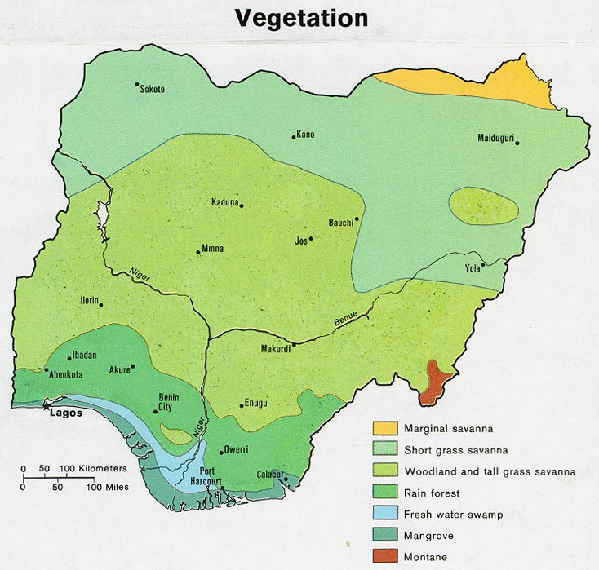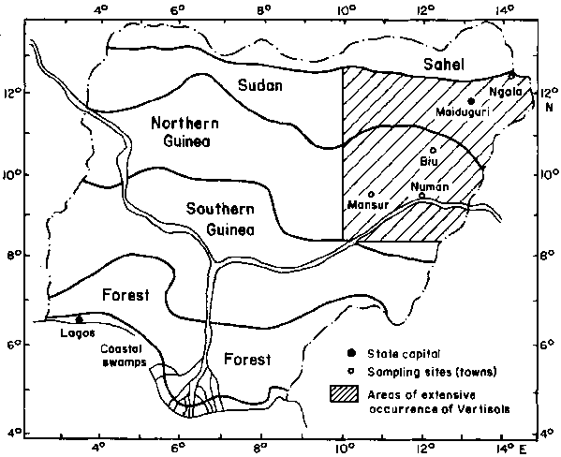

**FIELD TRIP ITINERERY**

The field trip for this session (2018/2019) was embarked on from May 20th to 24th 2019 and it was a journey to Oyo state, Niger State, Kwara State, North Eastern Nigeria. The schedule is as follows:

**Monday 27th of May, 2019:** Departure from Ile-Ife to Sepeteri, Oyo State with Botanical rambling at specific locations during the journey.

**Tuesday 28th of May, 2019:** A visit to the Old Oyo National Park, Sepeteri, Oyo State and the Journey to Ilorin, Kwara State.

**Wednesday** **29th of May, 2019:** A visit to Rice plantation in Jebba, Niger State.

**Thursday 30th of May, 2019:** A visit to Valentine Chicken, Banana/Plantain plantations in Shonga, Kwara State.

**Friday 31st of May, 2019**: A visit to Kwara State university teaching hospital, Return back to Ile-Ife, Osun State.

**CHAPTER TWO**

**Day 1: Journey to Sepeteri, Oyo State and Botanical Ramblings along Routes Taken**

The team comprising of about 122 students (part four A and B) and 13 staff members departed from the car park, Botany department, Obafemi Awolowo University around 9:07am on Monday 27th of May, 2019. The team left in a group of 6 in 4 coastal busses and 2 Hiace Buses. There were few or no academic stop overs as we were being conscious of time so as not to enter Sepeteri late.

**Observations from Ile-Ife to Sepeteri**

It was noticed that Ile-Ife and environs was of less farming activities but has some huge forest too, this was noticed along Ede road to Moro where our bus passed by vegetation composed of majorly trees, hence we enjoyed cooler breeze as we headed towards Oyo.

We got to Old Oyo National Park base camp around 5:20pm in the evening where we lodged and spend the night.

**Day 2**: We left the base camp around 7:30am on Tuesday 28th of May, 2019 and arrived at the national park around 9:00am where Mr. Garba A.B., the Assistant camp inspector where he familiarized us with the rules and regulations of the park. Dr Odiwe also addressed us and reminded us of what has been taught in class about the adaptive features of Savanna plants, such include; thin leaves, thick furrowed or fissured tree barks, rough fruit epidermis. He also pointed out that herbaceous plants are predominant in the vegetation. Dr. Ogbimi showed us some lower plants on the rocks where we were standing and Dr. Mankind also pointed out the presence of lower plants as a result of ***Archedium ohioensis***  in the

vegetation. Thereafter Mr. Emmanuel from Pax Herbal lead us in the identification of the plants in the park.

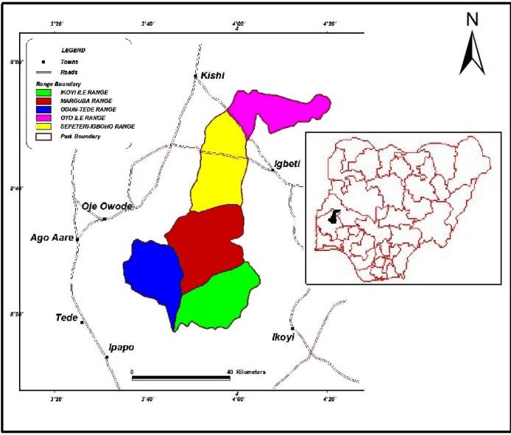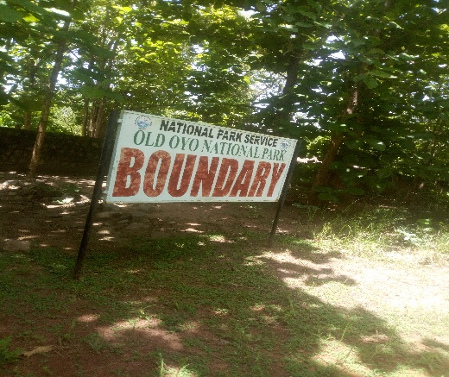

**Old Oyo**

**National Park. Location of the Park on the map.**

Old Oyo National Park is one of the national parks of Nigeria, located across northern Oyo State and Southern Kwara State, Nigeria. The park is 2,512km2 of land in northern Oyo state, southwest Nigeria, at latitude 8̊ 15'and 9̊ 00' and longitude 3̊ 35'’ and 4̊ 42'’E. The location has inevitably placed the park at a vantage position of abundance land areas as well as diverse wildlife and cultural/historical settings. The landscaping and organized space within the large yards has made the facility very endearing to the public. It is rich in plant and animal resources including buffaloes and a variety of birds.

Old Oyo National Park is the fourth largest national park in Nigeria. The park has the average rainfall 1,100mm per year. The vegetation is southern Guinea Savannah, the park can be sub-divided into four vegetation types, these consist of dense woodland and forest outliers in south-eastern part, mixed open savannah woodland in the central part, out crop vegetation in the northeast and riparian grassland and fringing woodland occupying the forest plains and the valleys along the Ogun River.

Distinctive features of the Southern Guinea Savannah plants of Old Oyo National Park include:

◾Most savannah plants branch are close to ground which means they are shrubs.

◾The trees have thick bark to survive fire.

◾The barks are furrowed and fissured to conserve water.

◾The stems of the plants are crooked.

The following plants were shown and described to us at the park:

**Journey from Sepeteri to Ilorin.**

After spending some hours at the old Oyo National Park, we stated our journey to Ilorin, Kwara State. Sparse vegetation was observed on the way for example along Ilorin road, a lot of grasses were seen by the road side.

Kwara state is located in the West-central area of Nigeria and lies in the region termed the Middle Belt of Nigeria. It is located in the forested savanna and enjoys moderate dry and wet seasons, with heavier rains falling in September and October. The derived guinea savanna grasslands dominate the Northern parts of the state, while some part of the southern Kwara falls within the rain forest agro-ecological zone of Nigeria.

Part of the state, especially those surrounding Asa Local Government is low lying Nigerian basement complex of between 300 to 400 meters above sea level. In some of the forested savanna areas of the state, a native African savanna tree, the *Prosopis africana* can be found. The tree is heavily used for such purposes as handles for hoes, chewing stick to protect gum decay, etc.

The state borders Niger State to the North, Kogi State to the East, Republic of Benin to the West and Oyo, Osun States to the South. Some of the rivers in the state are River Moro, Asa, Niger, Weru, Adere and Oshin. The State Capital is Ilorin which is also the largest city in the state.

We arrived at Fresh hotels in Ilorin where we lodged around 6pm. There were no more activities for the day as everyone went to rest in the rooms.

**CHAPTER THREE**

**Day 3: Visitation to Rice Plantation, Jebba, Niger State**

It has been 3 days in the course of the field trip and our next stop was in Rice plantations in Jebba, Niger State. We took off from fresh hotels early in the morning and got to Niger state after 3-4 hours.

At Jebba rice farm, we observed the large rice plantation. Dr Mrs. Bolaji a member of the Lecturers’ crew enlightened us more on the subject matter. Rice belongs to the genus *Oryza* and family Poaceace. It has a whole lot of species which resulted from hybridization of different species which include *Oryza sativa O. glaberrima, O. punctate, O. longistaminata, O. barthii,* etc. The *O. sativa* is an Asian rice. It produces white grains and the *O. glaberima* is the african rice which produces red seeds. The two rice species also have been hybridized which produced the Nenca Rice. The *O sativa* is known to be highly susceptible to disease and it is presently being improved by breeding for high rate of production. Rice growth majorly requires a lot of water, based on availability of water, there are two types:

**A) Upland rice** - These are grown where there is sufficient amount of rainfall

**B)** **Swampy rice** – This is grown in water logged areas.

**Dynamics of Jebba rice**

Breeding has been done to get the type of rice that will survive in the environment. The species include *Oryza nerica, O. sativa* and *O. longisteminata.*

A little description on rice is as follows:

◾Crossed rice doesn’t have a horn but wild rice has horn.

◾The last leaf is called flag leaf

◾The stem is called corm

◾The seed is called spikelet

◾When the spikelet is opened, the bigger one is called Palea while the smaller one is ◾called Lemma.

◾The whole branch is called panicle.

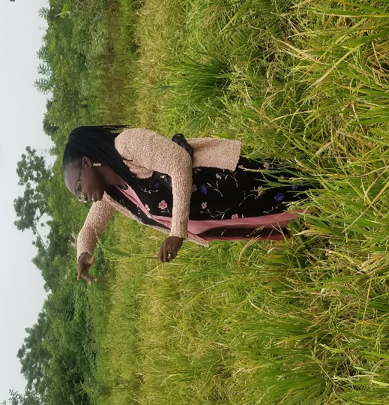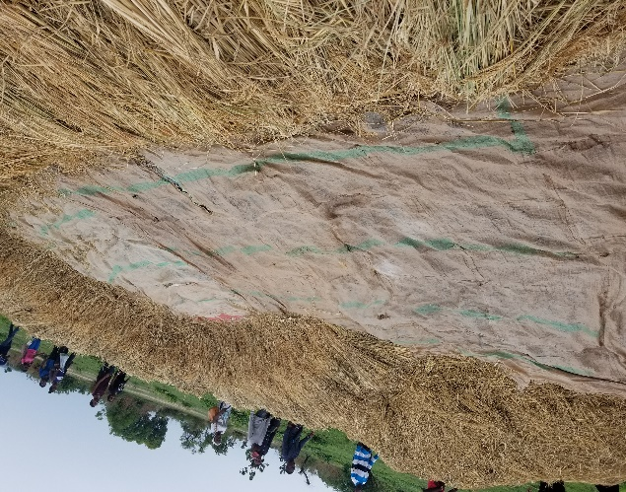◾The cluster of seed is called hull

**Dr. Bolaji talking about Rice Where the rice is being removed from the shafts**

Rice can be planted under various conditions, using various methods. It requires a lot of water to survive, hence it is planted either in a very swampy area, like along a river bank or in a place where irrigation is ssevere Rice is a staple food in several African countries and constitutes a bigger portion of diet on a regular basis. Statistically, Nigeria is the highest importer of rice globally and largest producer in West Africa. Jebba in Niger state is one of the state in Nigeria that cultivate rice in large quantity due to its swampy environment that result from the bank of river Niger. We were also shown some weeds found at the rice plantation by Mr Emmanuel.

Our exploits at Jebba ended after 2 hours and our journey back to Ilorin took around 3-4 hours. We arrived back at fresh hotels around 7pm.

**CHAPTER FOUR**

**Day 4: Visitation to Valentine Chickens and Banana Plantation in Shonga Village, Kwara State.**

We left Ilorin around 10:00am on Thursday to Shonga farm in Kwara State. At our arrival, birds were already being killed, eviscerated and packaged for storage. However, one of the staff took us around the factory showing facilities available for evisceration. We walked round the factory and took note of the abattoir, evisceration section, feathering section, and the packaging section. We were made to understand that 20,000 chickens are being slaughtered per day after which they are processed, packed in bags and stored in a cold room. Feathers from birds are processed into synthetic fibers, pillows, cushions, astronaut jackets, ladies wear and so on.

Our last stop in Shonga village was at a banana plantation close to Valentine Chickens. At the banana plantation, we observed the bananas for a very short period of time before being led out by the farm security officer. One of the Workers there was able to give us some explanations about the plantation before we left. He explained how the Banana are being planted, how many they allowed to grow on a spot and how the plantation is being irrigated.

We traveled back to Ilorin and retire to rest in fresh hotels around 6pm.

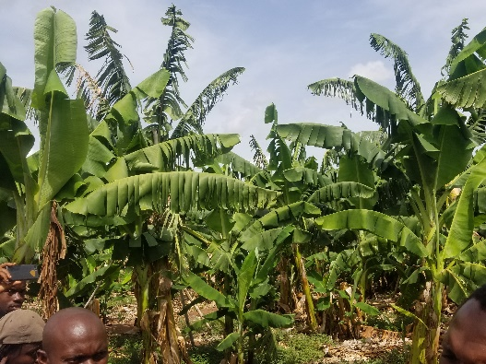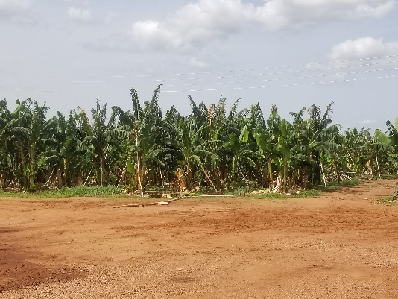

**At the Banana Plantation.**

**CHAPTER FIVE**

**Day 5: Journey back to Ile-Ife, Visitation to the Kwara State University Teaching Hospital.**

We departed from fresh hotels around 9am on the 31st of May, 2019 and got to Kwara state university teaching hospital around 11:30am. We were welcomed and ushered into a lecture room where we received a short lecture on the various environmental remediation works that are being practiced in the institute. The remediation practices include; waste management, according to Dr. Henry Sawyer, who is in charge of the Biosafety and Biotechnology Centre, Nigeria is top ranked among the nations of the world when it comes to open defecation, hence the University which was established for the sole aim of proffering solutions to environmental issues in the state worked with some organizations and provided many villages and towns with toilet facilities. These toilet facilities have helped to reduce open defecation to a bare minimum.

Dr. Henry Sawyer also took us through a session where he stated what the center does which include conducting certification training programs and short diploma courses such as Health safety and environment, HIA short courses, HIO short courses which are needed to make students resourceful after graduation as they move into the work industry. The center also conducts researches which are tailored towards a healthy environment, taking bioremediation as an example. He also mentioned that the location of the school as a city center provides an avenue for the school to engage in community development. The center has also championed a program called CLTS which means Community-Led Total Sanitation which has been executed in about 16 communities**.** Replying to the question asked by one of my colleagues, Dr. Sawyer familiarized us with the programs and how to apply for these programs.

After an hour spent at the teaching hospital, we left and headed back to Ile-Ife. We got to Ile-Ife some minutes after 5 in the evening. Mr. Isa made sure every head was counted before we were asked to return back to our various hostels. It was a relief as we were all happy to have returned hale and hearty from the educative, sight-seeing and adventurous field trip.

**CHAPTER SIX**

**Summary and Conclusion**

This field trip lasted for only five days but its impact will surely last forever. Seeing is believing they say. I went, saw, learned and documented.

The field trip has once again afforded me the opportunity to experience Botany, first hand. Corroborating what had been thought in class on the field was a nice experience, making things clearer and more interesting.

Having to mingle with colleagues in learning environments apart from the classroom and listening to dons and professionals lecture us practically on theoretical aspects of Botany was a memorable and satisfactory experience.

From plants recognizance in Old Oyo National Park to the lecture received at Kwara State University Teaching Hospital, all of them were educative and at the same time fun.

I would say the field trip should be a sessional business and not just 300L and 400L students, it should include also the 200L students and also allow the visitation to other important belts of the Country.

Appreciation goes to the organizers of the trip, for they have contributed immensely to my knowledge of Botany.

**APPENDIX**

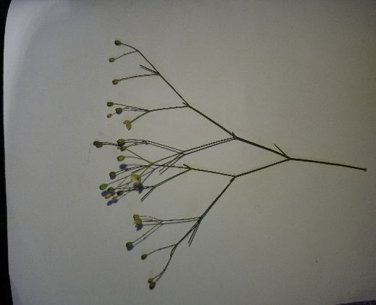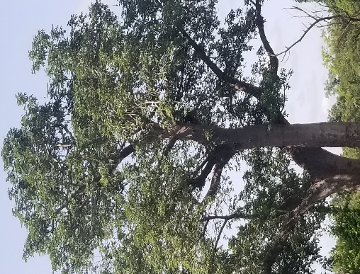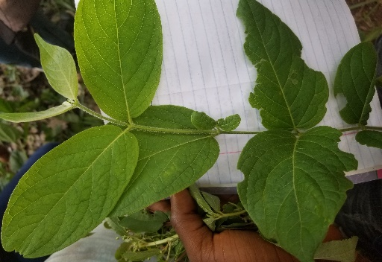

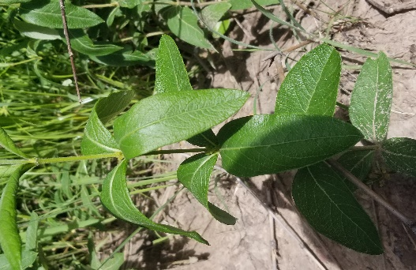

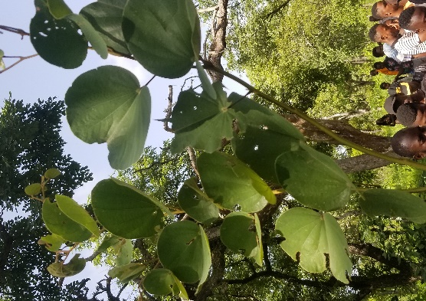

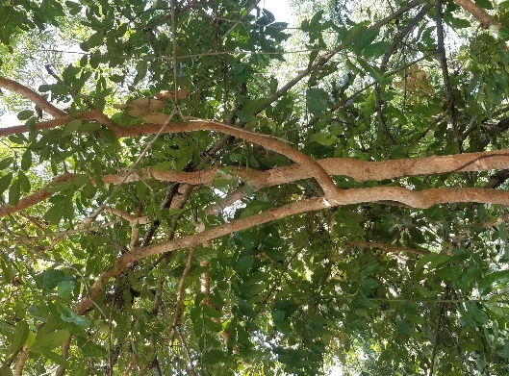

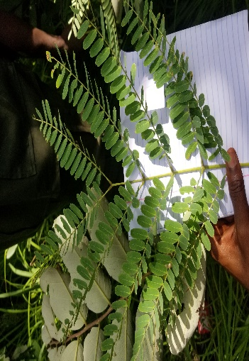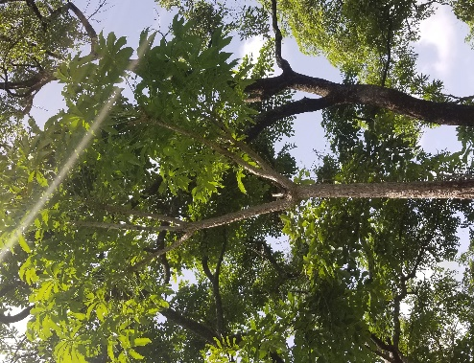

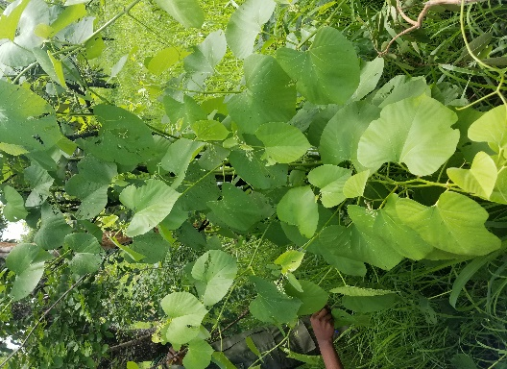

From left to right;

*Mollugo nudicaulos, Adansonia digitata, Hymenocardia aeida, Fadogia homblei, Piliostigma thonningii, Cissus pulpunea, Crosotynim sp, Prosopsis africana.*